

The School of Technology
BSc (Hons) in Software Engineering
(Batch - 08)
Software Architecture and Design
4CS017
student name (id):
2502339

Module Leader: Ms. Suranji Nadeeshani
Submission Date: 15/01/2025

The second iteration of the weather data prototype implements server-side caching using PHP and MySQL to reduce the frequency of requests to the OpenWeatherMap API. This approach not only optimize API usage but also increases system efficiency and responsiveness. The architecture stores frequently requested weather data in a MySQL database, enabling fast access. This provides a solid foundation, but continued refinements are essential to address its limitations and improve performance.

The strength of this lies in its ability to reduce latency and improve response times for end users. By caching weather data on the server, the system can serve data more quickly, especially for repeated requests. Additionally, this approach reduces the load on the OpenWeatherMap API and reduces the cost associated with its use. The use of PHP and MySQL, which are widely used technologies, builds the system on a powerful and scalable platform.

one significant weakness is the potential for data lack of similarities. Cached data can become outdated, leading to incorrectness in the weather information provided. Implementing and maintaining the caching mechanism adds complexity to the system, requiring additional logic to manage cache expiration and updates.

One challenge here is determining an optimal caching strategy, such as setting appropriate expiration times for cached data to balance freshness and performance. Handling high traffic can be tiring for the server. Future enhancements could further improve system efficiency by integrating a mechanism to selectively update cached data based on patterns. The use of micro service architectures can be explored to help distribute the load more effectively and improve the overall system resiliency and improve the overall system resilience.

Conclusion is implementing server-side caching with PHP and MySQL increases system efficiency by reducing API calls and improving response times.

This is my database,

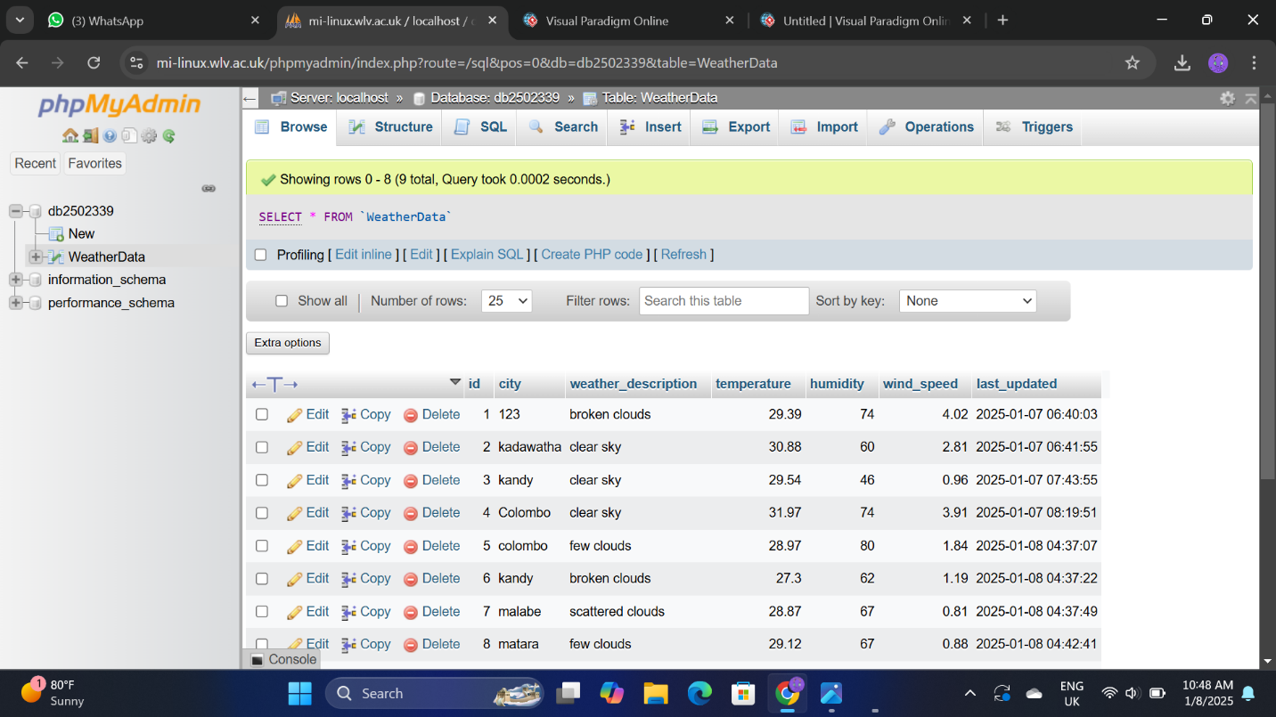

This is my Prototype 2 link,
https://mi-linux.wlv.ac.uk/~2502339/saduni_1/index.html

